GIT HUB
1
- What is Git Hub?
- GitHub is a code hosting platform for collaboration and version control.GitHub lets you (and others) work together on projects.
- Git Hub essentials are:
  - Repositories
  - Branches
  - Commits
  - Pull Requests
  - Git (the version control software GitHub is built on)

Repository
    - A GitHub repository can be used to store a development project.
    - It can contain folders and any type of files (HTML, CSS, JavaScript, Documents, Data, Images).
    - A GitHub repository should also include a licence file and a README file about the project.
    - A GitHub repository can also be used to store ideas, or any resources that you want to share.

Branch
A GitHub branch is used to work with different versions of a repository at the same time.
By default a repository has a master branch (a production branch).
Any other branch is a copy of the master branch (as it was at a point in time).
New Branches are for bug fixes and feature work separate from the master branch. When changes are ready, they can be merged into the master branch. If you make changes to the master branch while working on a new branch, these updates can be pulled in.
- Commits
  - At GitHub, changes are called commits.
  - Each commit (change) has a description explaining why a change was made.
- Pull Requests
  - Pull Requests are the heart of GitHub collaboration.
  - With a pull request you are proposing that your changes should be merged (pulled in) with the master.
  - Pull requests show content differences, changes, additions, and subtractions in colors (green and red).
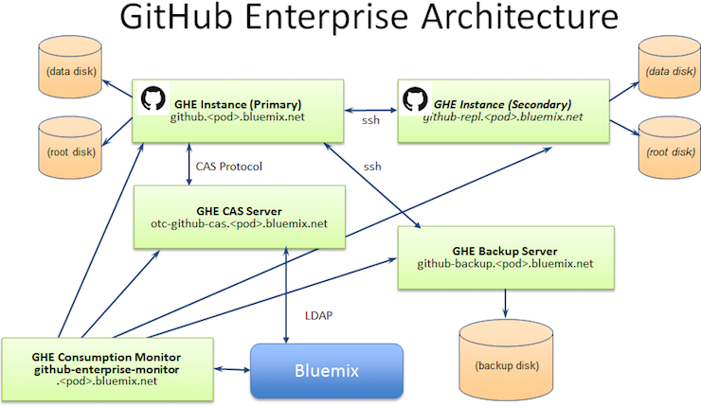
  - As soon as you have a commit, you can open a pull request and start a discussion, even before the code is finished.
  - How GIT HUB Works?
  - The core of Github is the open-source software git, which is a distributed version control and source code management software. Github adds many features onto git's functionality, including issue tracking, wiki, access control, etc.
  - However, Github is proprietary software, and many of it's internals remain unknown to general public.
In order to find out how pieces are fit together, I suggest following the leads below:
Github's official Engineering Blog, which covers a wide range of topics of the design of the platform.
- Projects that power Github, an officially curated list of open-source projects that power Github.
- Here are a few highlights:
  - rails - web backend
  - jekyll - blog engine behind Github Pages
  - elasticsearch - search engine
  - hubot - a chat bot for task automation
  - ace - browswer based code editor
  - d3 - js lib for graphs and charts

  - resque - background works
itLaGb, an open-source alternative to Github, which offers pretty much the same functionalities.
- Read the source code of GitLab and you'll get to know how GitLab (and Github as well) works under the hood.
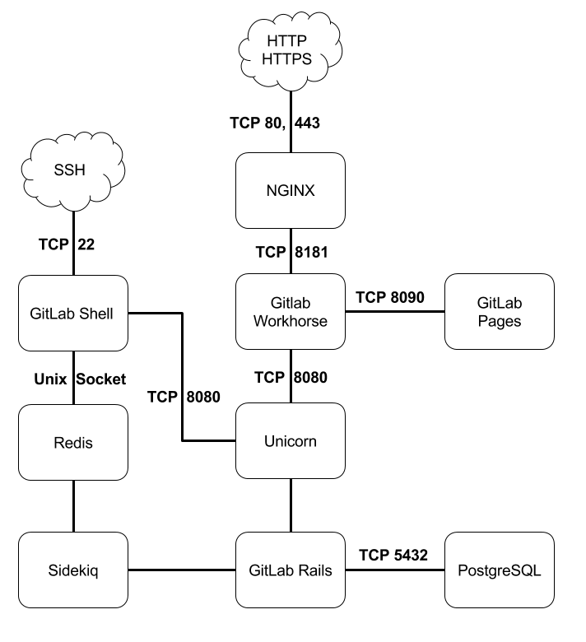
- GitLab Architecture Overview. This article is definitely a good entry point.I stole a system layout diagram from Gitlab Architecture Overview. Bet you've already get a hang of how gitlab works from this diagram.(There surely are lots of difference between Github and GitLab. But an open-source project is always better for someone who wants to l earn, isn't it?)
How do I open a GitHub account?
- Step 1 :-Go to the GitHub sign up page.
- Step 2:-Enter a username, valid email address, and password.Use at least one lowercase letter, one numeral, and seven characters.
- Step 3:-Review carefully the GitHub Terms of Service and Privacy Policy before continuing.
- Step 4:-Choose a plan. ...
- Step 5:-Tailor experience. ...
- Step 6:-You finished!
- Adding a file to a GIT HUB
- Step1:-On GitHub, navigate to the main page of the repository.
- Step2:-nder your repository name, click Upload files.
- Step3:-Drag and drop the file or folder you'd like to upload to your repository onto the file tree.
- Step4:-At the bottom of the page, type a short, meaningful commit message that describes the change you made to the file. You can attribute the commit to more than one author in the commit message. For more information, see "Creating a commit with multiple co-authors."
- Step5:-Below the commit message fields, decide whether to add your commit to the current branch or to a new branch. If your current branch is master, you should choose to create a new branch for your commit and then create a pull request.
- Step6:-Click Commit changes.
What is Git?
- So, what is Git in a nutshell? This is an important section to absorb, because if you understand what Git is and the fundamentals of how it works, then using Git effectively will probably be much easier for you. As you learn Git, try to clear your mind of the things you may know about other VCSs, such as CVS, Subversion or Perforce — doing so will help you avoid subtle confusion when using the tool. Even though Git’s user interface is fairly similar to these other VCSs, Git stores and thinks about information in a very different way, and understanding these differences will help you avoid becoming confused while using it.
- The major difference between Git and any other VCS (Subversion and friends included) is the way Git thinks about its data. Conceptually, most other systems store information as a list of file-based changes. These other systems (CVS, Subversion, Perforce, Bazaar, and so on) think of the information they store as a set of files and the changes made to each file over time (this is commonly described as delta-based version control).
- This is an important distinction between Git and nearly all other VCSs. It makes Git reconsider almost every aspect of version control that most other systems copied from the previous generation. This makes Git more like a mini filesystem with some incredibly powerful tools built on top of it, rather than simply a VCS. We’ll explore some of the benefits you gain by thinking of your data this way when we cover Git branching in Git Branching.
- Git development began in April 2005, after many developers of the Linux kernel gave up access to BitKeeper, a proprietary source-control management (SCM) system that they had formerly used to maintain the project.[14] The copyright holder of BitKeeper, Larry McVoy, had withdrawn free use of the product after claiming that Andrew Tridgell had reverse-engineered the BitKeeper protocols.[15] (The same incident would also spur the creation of another version-control system, Mercurial.)
- Linus Torvalds wanted a distributed system that he could use like BitKeeper, but none of the available free systems met his needs. Torvalds cited an example of a source-control management system needing 30 seconds to apply a patch and update all associated metadata, and noted that this would not scale to the needs of Linux kernel development, where synchronizing with fellow maintainers could require 250 such actions at once. For his design criteria, he specified that patching should take no more than three seconds,[9] and added three more points:
- Git stores each newly created object as a separate file. Although individually compressed, this takes a great deal of space and is inefficient. This is solved by the use of packs that store a large number of objects delta-compressed among themselves in one file (or network byte stream) called a packfile. Packs are compressed using the heuristic that files with the same name are probably similar, but do not depend on it for correctness. A corresponding index file is created for each packfile, telling the offset of each object in the packfile. Newly created objects (with newly added history) are still stored as single objects, and periodic repacking is needed to maintain space efficiency. The process of packing the repository can be very computationally costly. By allowing objects to exist in the repository in a loose but quickly generated format, Git allows the costly pack operation to be deferred until later, when time matters less, e.g., the end of a work day. Git does periodic repacking automatically, but manual repacking is also possible with the git gc command. For data integrity, both the packfile and its index have an SHA-1 checksum inside, and the file name of the packfile also contains an SHA-1 checksum. To check the integrity of a repository, run the git fsck comman
- Q-3
- #include<stdio.h>
- #include<stdlib.h>
- char s[100],m;
- int top=-1,n=100;
- FILE *fp;

- void push(char m)
- {

- if(top>=n-1)
- {
- printf("\n Stake is overflow");
- }
- else
- {
- top++;
- s[top]=m;
- }
- }
- void pop()

- {

- if (top == -1)

- {

- printf("expression is invalid\n");

- exit(0);

- }

- else

- {

- top--;

- }

- }
- void find_top()

- {

- if (top == -1)

- printf("\nexpression is valid\n");

- else

- printf("\nexpression is invalid\n");

- }

- int main()
- {
- char d;
- fp=fopen("p3.txt","r+");
- while((fscanf(fp,"%c",&d))!=EOF)
- {
- if (d == '(')

- {

- push(d);

- }

- else if (d == ')')

- {

- pop();

- }
- //push(d);
- }
- find_top();
- }
- O/P:-
- yash@yash-Lenovo-ideapad-310-15ISK:~/Ass1$ gcc p3.c
- yash@yash-Lenovo-ideapad-310-15ISK:~/Ass1$ ./a.out

- expression is invalid
- yash@yash-Lenovo-ideapad-310-15ISK:~/Ass1$ ^C
- yash@yash-Lenovo-ideapad-310-15ISK:~/Ass1$ gcc p3.c
- yash@yash-Lenovo-ideapad-310-15ISK:~/Ass1$ ./a.out

- expression is invalid
- yash@yash-Lenovo-ideapad-310-15ISK:~/Ass1$
- Q-4
- #include<stdio.h>
- #include<stdlib.h>
- FILE *fp;
- struct node{
- int data;
- struct node *next;
- }*head=NULL;
- void Insert(int item)
- {
- //int item;
- struct node *temp,*newnode;
- newnode=(struct node*)malloc(sizeof(struct node));
- if(newnode == NULL)
- printf("Error: Assigning Memory\n");
- // printf("Insert Data At Last : ");
- //scanf("%d",&item);
- newnode->data=item;
- temp=head;
- if(head == NULL)
- {
- head=newnode;
- newnode->next=NULL;
- }
- else
- {
- while(temp->next != NULL)
- {
- temp=temp->next;
- }
- temp->next=newnode;
- newnode->next=NULL;
- }

- }
- void removeduplicate()
- {
- struct node *tmp,*curr,*del,*prev;
- tmp=head;
- while(tmp)
- {
- curr=tmp->next;
- prev=tmp;
- while(curr)
- {
- if(curr->data == tmp->data)
- {
- del=curr;

- prev->next=curr->next;
- curr=curr->next;
- free(del);

- }
- else
- {
- prev=curr;
- curr=curr->next;

- }

- }
- tmp=tmp->next;
- }
- }
- void display()
- {
- struct node *tmp;
- tmp=head;
- while(tmp)
- {
- printf("\n%d",tmp->data);
- tmp=tmp->next;
- }
- }
- int main()
- {
- fp=fopen("p4.txt","r+");
- int x,c=0;
- //fscanf(fp,"%d",&x);
- while((fscanf(fp,"%d",&x))!=EOF)
- {
- Insert(x);
- c++;
- }
- printf("\n The total number of nodes are %d",c);
- printf("Link list element");
- display();
- removeduplicate();
- printf("\nLink list after remove duplicate ");
- display();
- }
- O/P:-
- yash@yash-Lenovo-ideapad-310-15ISK:~/Ass1$ gcc p4.c
- yash@yash-Lenovo-ideapad-310-15ISK:~/Ass1$ ./a.out

- The total number of nodes are 11Link list element
- 45
- 22
- 77
- 8
- 99
- 44
- 33
- 95
- 44
- 33
- 99
- Link list after remove duplicate
- 45
- 22
- 77
- 8
- 99
- 44
- 33
- 95yash@yash-Lenovo-ideapad-310-15ISK:~/Ass1$
- #include<stdio.h>
- #include<stdlib.h>
- struct Node
- {
- int data;
- struct Node *next;
- }*head;
- int c=0;
- FILE *fp;

- void push(int val)
- {
- struct Node *new=(struct Node *)malloc(sizeof(struct Node));
- new->data=val;
- new->next=head;
- head=new;
- c++;
- }
- int pop()
- {
- int val=0;
- if(head==NULL)
- printf("Stack underflow");
- else
- {
- struct Node *tmp=head;
- val=tmp->data;
- head=tmp->next;
- free(tmp);
- }
- return val;
- }
- void display()
- {
- if(head==NULL)
- printf("Stack underflow");
- else
- {
- struct Node *tmp=head;
- while(tmp!=NULL)
- {
- printf("%d\t",tmp->data);
- tmp=tmp->next;
- }
- }
- }
- int peek(int i)
- {
- if(c-i<0)
- printf("stack underflow\n");
- else
- {
- struct Node *tmp=head;
- int j;
- for(j=1;j<i;j++)
- {
- tmp=tmp->next;
- }
- return tmp->data;
- }
- }
- void change(int i,int val)
- {
- if(c-i<0)
- printf("stack underflow\n");
- else
- {
- struct Node *tmp=head;
- int j;
- for(j=1;j<i;j++)
- {
- tmp=tmp->next;
- }
- tmp->data=val;
- printf("\nValue changed !");
- }
- }
- int main()
- {
- int ch=1,val,new;
- fp=fopen("p8.txt","r");
- while(ch!=0)
- {
- printf("\n1.push\n2.pop\n3.disply\n4.peek\n5.change\n0.break");
- printf("\nEnter choice");
- scanf("%d",&ch);
- switch(ch)
- {
- case 1:

- if((fscanf(fp,"%d",&val))==EOF)
- {
- printf("No data availble in file for push");
- break;
- }
- push(val);
- break;
- case 2:
- printf("popped value %d",pop());
- break;
- case 3:
- display();
- break;
- case 4:
- printf("Enter position of peek value ");
- scanf("%d",&val);
- printf("Peeked value : %d",peek(val));
- break;
- case 5:
- printf("Enter postion of value want to change");
- scanf("%d",&val);
- printf("Enter new value");
- scanf("%d",&new);
- change(val,new);
- break;

- }
- }

- }
- yash@yash-Lenovo-ideapad-310-15ISK:~/Ass1$ gcc p8.c
- yash@yash-Lenovo-ideapad-310-15ISK:~/Ass1$ ./a.out

- 1.push
- 2.pop
- 3.disply
- 4.peek
- 5.change
- 0.break
- Enter choice1

- 1.push
- 2.pop
- 3.disply
- 4.peek
- 5.change
- 0.break
- Enter choice3
- 66
- 1.push
- 2.pop
- 3.disply
- 4.peek
- 5.change
- 0.break
- Enter choice^C
#include<stdio.h>
- #include<stdlib.h>
- struct Node
- {
- int val;
- struct Node *next;
- }*f=NULL,*r=NULL;
- FILE *fp;
- void enqueue(int va)
- {
- struct Node *newnode;
- newnode=(struct Node *)malloc(sizeof(struct Node));
- newnode->val=va;
- newnode->next=NULL;
- if(r==NULL)
- {
- r=newnode;
- f=newnode;
- }
- else
- {
- r->next=newnode;
- r=newnode;
- }
- printf("Value inserted %d",va);
- }
- int dequeue()
- {
- struct Node *newnode=f;
- int tmp;
- if(f==NULL)
- printf("Queue empty");
- else
- {
- tmp=f->val;
- if(f->next==NULL)
- f=r=NULL;
- else
- f=f->next;
- }
- free(newnode);
- return tmp;

- }
- void display()
- {
- struct Node *tmp=f;
- if(tmp==NULL)
- printf("Queue empty");
- else
- {

- while(tmp)
- {
- printf("%d\t",tmp->val);
- tmp=tmp->next;
- }
- }
- }
- int main()
- {
- int ch,val;
- fp=fopen("p9.txt","r");
- while(1)
- {
- printf("\n---------menu---------");
- printf("\n1.Insert \n2.delete\n3.display\n4.Exit\n");
- printf("Enter choice ");
- scanf("%d",&ch);
- switch(ch)
- {
- case 1 :
- if((fscanf(fp,"%d",&val))==EOF)
- {
- printf("No data availble in file for push");
- break;
- }
- enqueue(val);
- break;
- case 2:
- val=dequeue();
- printf("\nDeleted valude = %d",val);
- break;
- case 3:
- display();
- break;
- case 4:
- exit(1);
- break ;
- default :
- printf("Invalid choice try again ");
- break;
- }
- }
- }
- yash@yash-Lenovo-ideapad-310-15ISK:~/Ass1$ gcc p9.c
- yash@yash-Lenovo-ideapad-310-15ISK:~/Ass1$ ./a.out

- ---------menu---------
- 1.Insert
- 2.delete
- 3.display
- 4.Exit
- Enter choice 1
- Value inserted 78
- ---------menu---------
- 1.Insert
- 2.delete
- 3.display
- 4.Exit
- Enter choice
- Q-10
- #include<stdio.h>
- #define N 1000
- FILE *fp;
- int a[N];
- int top=-1;
- int isempty()
- {
- if(top==-1)
- return 1;
- else
- return 0;
- }
- int isfull()
- {
- if(top==N-1)
- return 1;
- else
- return 0;
- }
- void push(int val)
- {
- if(isfull()==1)
- {
- printf("\nStack is overflow");
- }
- else
- {
- top++;
- a[top]=val;
- display();

- }
- }
- int pop()
- {
- int tmp;
- if(isempty()==1)
- {
- printf("\nStack is underflow");

- return -1;
- }
- else
- {
- tmp=a[top];
- top--;
- return tmp;
- }
- }
- int peek(int i)
- {
- if(top+1-i<0)
- printf("\n Stack underflow");
- else
- return a[top+1-i];
- }
- void change(int i,int val)
- {

- if(top+1-i<0)
- printf("\n Stack underflow");
- else
- a[top+1-i]=val;
- }
- void display()
- {
- int i;
- if(isempty()==1)
- printf("Stack undeflow");
- else
- {
- for(i=top;i>=0;i--)
- {
- printf("%d \t",a[i]);
- }
- }
- }
- void main()
- {
- int ch,val,i;
- fp=fopen("p10.txt","r");
- while(1)
- {
- printf("\n----Menu-----");
- printf("\n1.push");
- printf("\n2.pop");
- printf("\n3.peek");
- printf("\n4.change");
- printf("\n5.display");
- printf("\n6.Exit");
- printf("\nEnter choice : ");
- scanf("%d",&ch);
- switch(ch)
- {
- case 1:
- if((fscanf(fp,"%d",&val))==EOF)
- {
- printf("No data availble in file for push");
- break;
- }
- push(val);
- break;
- case 2:
- val=pop();
- if(val!=-1)
- printf("Poped value : %d ",val);

- break;
- case 3:
- printf("\nEnter position : ");
- scanf("%d",&i);
- printf("\npeeked value : %d",peek(i));
- break;
- case 4:
- printf("\nEnter position : ");
- scanf("%d",&i);
- printf("\nEnter new value : ");
- scanf("%d",&val);
- change(i,val);
- break;
- case 5:
- display();
- break;
- case 6:
- exit(0);
- break;
- default:
- printf("\nInvalid choice : ");
- break;

- }

- }
- }
- o/p:-
- yash@yash-Lenovo-ideapad-310-15ISK:~/Ass1$ gcc p10.c
- p10.c: In function ‘push’:
- p10.c:30:4: warning: implicit declaration of function ‘display’ [-Wimplicit-function-declaration]
- display();
- ^~~~~~~
- p10.c: At top level:
- p10.c:65:6: warning: conflicting types for ‘display’
- void display()
- ^~~~~~~
- p10.c:30:4: note: previous implicit declaration of ‘display’ was here
- display();
- ^~~~~~~
- p10.c: In function ‘main’:
- p10.c:125:6: warning: implicit declaration of function ‘exit’ [-Wimplicit-function-declaration]
- exit(0);
- ^~~~
- p10.c:125:6: warning: incompatible implicit declaration of built-in function ‘exit’
- p10.c:125:6: note: include ‘<stdlib.h>’ or provide a declaration of ‘exit’
- yash@yash-Lenovo-ideapad-310-15ISK:~/Ass1$ ./a.out

- ----Menu-----
- 1.push
- 2.pop
- 3.peek
- 4.change
- 5.display
- 6.Exit
- Enter choice :
- Q-11
- #include<stdio.h>
- #define MAX 50
- void insert(int);
- void delete();
- void display();
- int queue_array[MAX];
- int rear = - 1;
- int front = - 1;
- FILE *fp;
- int main()
- {
- int x,choice;

- fp = fopen("p11.txt","r");

- while (1)

- {

- printf("1.Insert element to queue \n");

- printf("2.Delete element from queue \n");

- printf("3.Display all elements of queue \n");

- printf("4.Quit \n");

- printf("Enter your choice : ");

- scanf("%d", &choice);

- switch (choice)

- {

- case 1:

- if((fscanf(fp,"%d",&x))==EOF)
- {
- printf("No data availble in file for push");
- break;
- }
- insert(x);

- break;

- case 2:

- delete();

- break;

- case 3:

- display();

- break;

- case 4:

- exit(1);

- default:

- printf("Wrong choice \n");

- }

- }

- }
- void insert(int add_item)

- {

- // ;

- if (rear == MAX - 1)

- printf("Queue Overflow \n");

- else

- {

- if (front == - 1)

- /*If queue is initially empty */

- front = 0;

- // printf("Inset the element in queue : ");

- //scanf("%d", &add_item);

- rear = rear + 1;

- queue_array[rear] = add_item;

- }

- }

- void delete()

- {

- if (front == - 1 || front > rear)

- {

- printf("Queue Underflow \n");

- return ;

- }

- else

- {

- printf("Element deleted from queue is : %d\n", queue_array[front]);

- front = front + 1;

- }

- }

- void display()

- {

- int i;

- if (front == - 1)

- printf("Queue is empty \n");

- else

- {

- printf("Queue is : \n");

- for (i = front; i <= rear; i++)

- printf("%d ", queue_array[i]);

- printf("\n");

- }

- }
- O/P:-
- yash@yash-Lenovo-ideapad-310-15ISK:~/Ass1$ ./a.out
- 1.Insert element to queue
- 2.Delete element from queue
- 3.Display all elements of queue
- 4.Quit
- Enter your choice : 1
- 1.Insert element to queue
- 2.Delete element from queue
- 3.Display all elements of queue
- 4.Quit
- Enter your choice : 3
- Queue is :
- 78
- 1.Insert element to queue
- 2.Delete element from queue
- 3.Display all elements of queue
- 4.Quit
- Enter your choice : ^C
- yash@yash-Lenovo-ideapad-310-15ISK:~/Ass1$
- Q-12
- #include<stdio.h>
- #include<string.h>
- #define N 10
- char a[N];
- int top=-1;
- FILE *fp;
- int isempty()
- {
- if(top==-1)
- return 1;
- else
- return 0;
- }
- int isfull()
- {
- if(top==N-1)
- return 1;
- else
- return 0;
- }
- void push(char val)
- {
- if(isfull()==1)
- {
- printf("\nStack is overflow");
- }
- else
- {
- top++;
- a[top]=val;
- }
- }
- char pop()
- {
- char tmp;
- if(isempty()==1)
- {
- printf("\nStack is underflow");

- return -1;
- }
- else
- {
- tmp=a[top];
- top--;
- return tmp;
- }
- }
- void main()
- {
- char *original,c,*reverse;
- int i=0,flag=0;
- fp=fopen("p12.txt","r");
- printf("original string :");
- fscanf(fp,"%s",original);
- while(original[i] != '\0')
- {
- push(original[i]);
- printf("%c",original[i]);
- i++;
- }
- i=0;
- printf("\nReverse string : ");
- while(!isempty())
- {
- c=pop();
- printf("%c",c);
- reverse[i]=c;
- i++;
- }
- i=0;
- while(original[i]!='\0' && reverse[i]!='\0')
- {
- printf("%c - %c\n",original[i],reverse[i]);
- if(original[i] != reverse[i])
- {
- flag=1;
- break;
- }
- i++;
- }
- if(flag==1)
- printf("\nString is not palindogram ");
- else
- printf("\nString is palindogram");
- }
- O/p:-
- yash@yash-Lenovo-ideapad-310-15ISK:~/Ass1$ gcc p12.c
- yash@yash-Lenovo-ideapad-310-15ISK:~/Ass1$ ./a.out
- original string :rar
- Segmentation fault (core dumped)
- yash@yash-Lenovo-ideapad-310-15ISK:~/Ass1$

MA014
3 MA014

